Steps in creating the Spring Pet Clinic Project

- Create a git hub repo
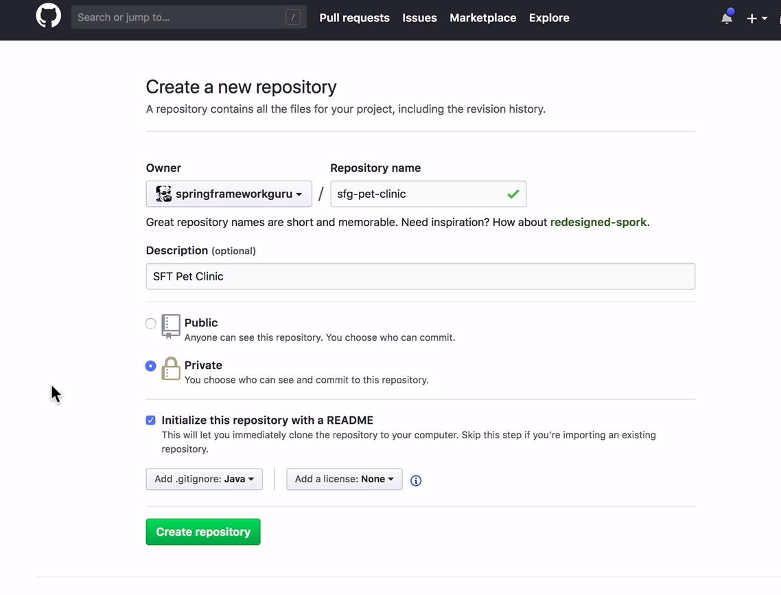
- Clone the github repo to your local machine in the working directory of choice
  - Make sure one is not in a git repo already.
>git status
fatal: not a git repository (or any of the parent directories): .git
  - clone from github
> git clone url
  - change to new created git directory
> cd directoryName
  - display contents
>ls -ltra
The ls command is used for listing the contents of a directory. The lrt part is a combination of three different options:

l: This is for the long listing of the contents. It shows one file in each line with additional info such as permissions, ownership, size, timestamps etc.
t: This one sorts the long listing output based on time.
r: This one reverses the order of ls command output.

- Create Spring-boot project from https://start.spring.io/
add dependencies
  - Spring WEB
  - Lombok
  - Thymeleaf
  - H2
  - MySQL
  - Spring Data JPA
  - Spring boot actuator
  - Spring boot dev tools
Group → guru.springframework
artifact same a project directory (Just a convention) → sfg-pet-clinic
name → sfg-pet-clinic
description → SFG Pet Clinic Project
maven project, Java, Jar
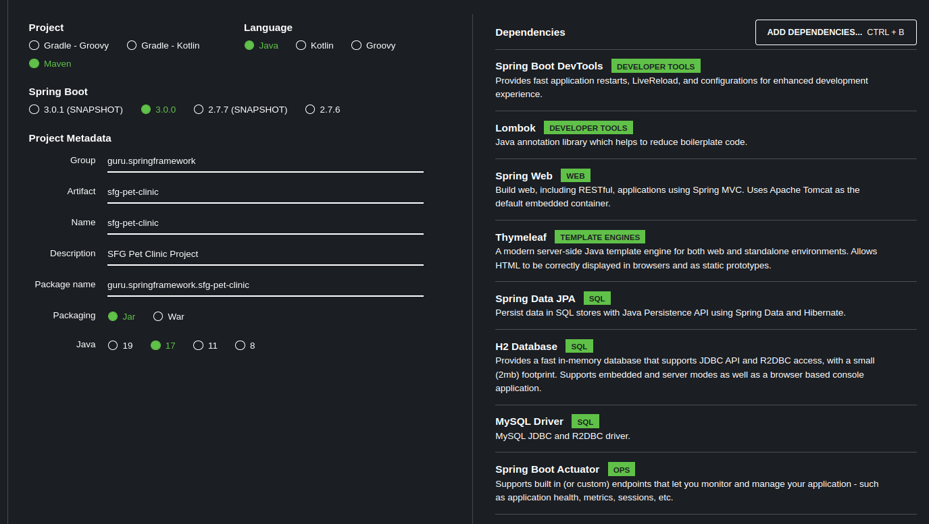

- Extract the contents to my newly created sfg-pet-clinic directory
- add and commit changes

4. Open project in IntelliJ
- Update .ignore to Springframework-guru’s .gitinore file
- create a remote to upstream so I can use git compare function
>git remote add upstream url
> git fetch remote master
- add and commit changes the push to origin
> git add .
> git commit -m “some message”
> git push origin master

- Project management → create isssues in Github
  - Create Multi-Module Project for Data Model
  - Implement Pet Clinic POJO Data Model
  - Add Maven Release Plugin
  - Upgrade to JUNIT 5
  - Create interfaces for Pet Clinic Services
  - Implement Map Based Services
  - Create Pet Clinic Controllers
  - Add Pet Clinic index Page and Controller
  - Add WebJars for Bootstrap CSS and Jquery

Lesson 47 POJO Data Model

On the master branch

Here I assign the Issue “Implement Pet Clinic POJO Data Model” on gitHub to myself.

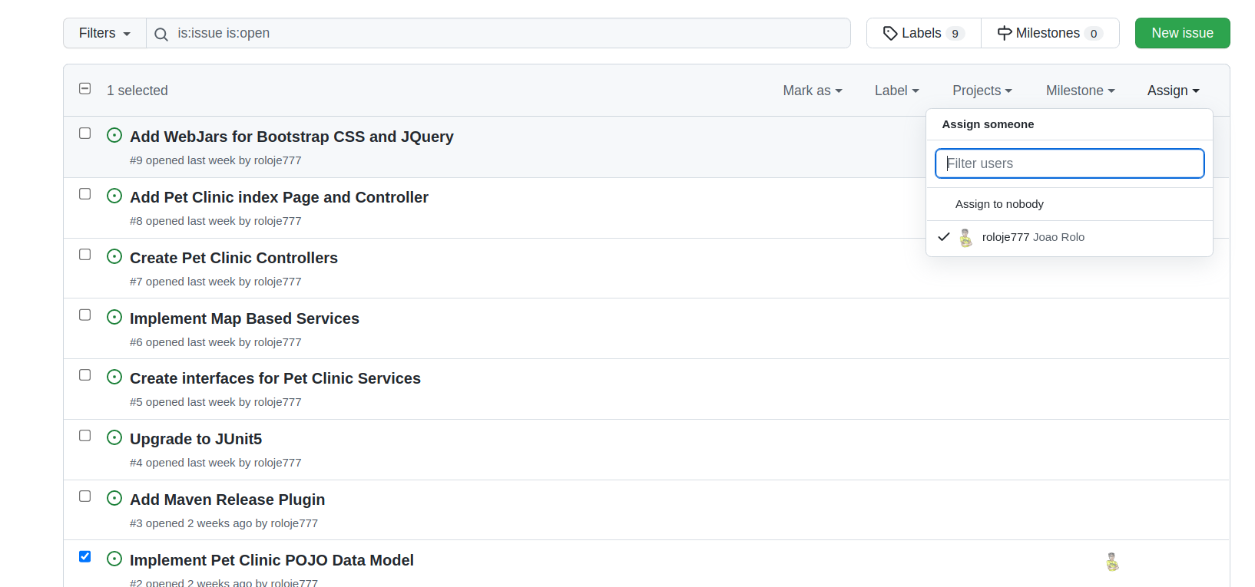Figure 1: Assigning an issue

- and create a simple POJO Model for the Pet Clinic.

Under the model package

Drawing 1: Person.java
package guru.springframework.sfgpetclinic.model;
public class Person {
private String firstName;
private String lastName;
public String getFirstName() {
return firstName;
}
public void setFirstName(String firstName) {
this.firstName = firstName;
}
public String getLastName() {
return lastName;
}
public void setLastName(String lastName) {
this.lastName = lastName;
}
}

Drawing 2: Owner.java
package guru.springframework.sfgpetclinic.model;
public class Owner extends Person{
}

Drawing 3: Vet.java
package guru.springframework.sfgpetclinic.model;
public class Vet extends Person{
}

Drawing 4: Pet.java
package guru.springframework.sfgpetclinic.model;
import java.time.LocalDate;
public class Pet {
private PetType petType;
private Owner owner;
private LocalDate birthDate;
public PetType getPetType() {
return petType;
}
public void setPetType(PetType petType) {
this.petType = petType;
}
public Owner getOwner() {
return owner;
}
public void setOwner(Owner owner) {
this.owner = owner;
}
public LocalDate getBirthDate() {
return birthDate;
}
public void setBirthDate(LocalDate birthDate) {
this.birthDate = birthDate;
}
}

Drawing 5: PetType.java
package guru.springframework.sfgpetclinic.model;
public class PetType {
private String name;
public String getName() {
return name;
}
public void setName(String name) {
this.name = name;
}
}

Next I commit and push using IntelliJ this time.
I add a comment and close the issue as well.
Right click Project Directory → Git → commit Directory.

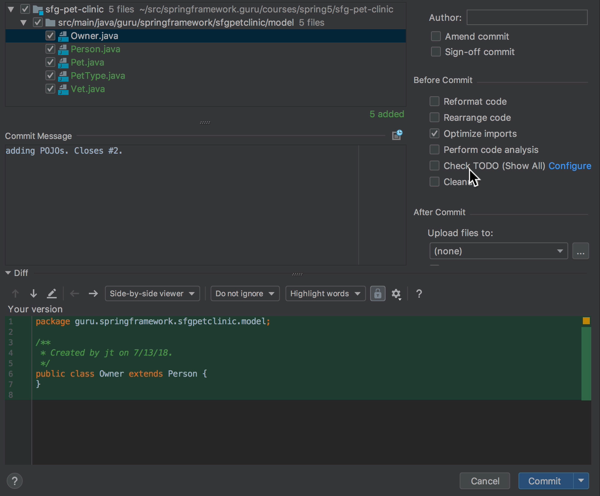
Note the comment “closes #2.
This closes the issue #2 in github as well

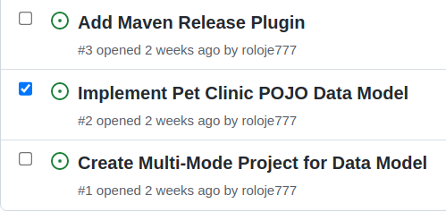

Lesson 48 – Spring Pet Project – Multi-Maven Project

Note that as of pring 2.1 the POM settup to disable packaging changed. (no Main class found issue)

- I Assign issue #1 to myself (Figure 1)

- Create new Modules Project name → new → module

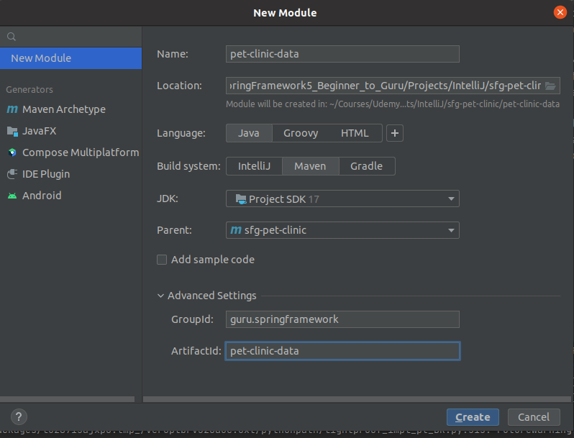Figure 2: Data Module

- Move the SfgPetClinicApplication.java to the Web module and the model to the data module

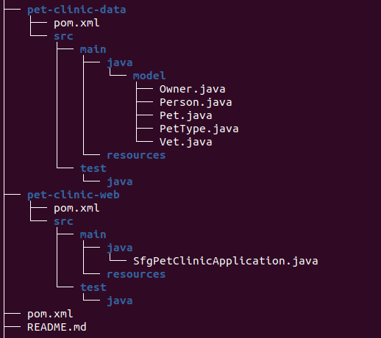Figure 3: move applicationa and module

- do the following top pom data

Action | Info | From Pom | To Pom
Move | <dependency>  <groupId>org.springframework.boot</groupId>  <artifactId>spring-boot-starter-actuator</artifactId>  </dependency> | from Project pom | pet-clinic-web
Delete | <properties>  <maven.compiler.source>17</maven.compiler.source>  <maven.compiler.target>17</maven.compiler.target>  <project.build.sourceEncoding>UTF-8</project.build.sourceEncoding>  </properties> |  | pet-clinic-web
Move | <dependency>  <groupId>org.springframework.boot</groupId>  <artifactId>spring-boot-starter-data-jpa</artifactId>  </dependency> | Project pom | pet-clinic-model
delete | <properties>  <maven.compiler.source>17</maven.compiler.source>  <maven.compiler.target>17</maven.compiler.target>  <project.build.sourceEncoding>UTF-8</project.build.sourceEncoding>  </properties> |  | pet-clinic-model
Action | Info | From Pom | To Pom
Move | <dependency>  <groupId>com.h2database</groupId>  <artifactId>h2</artifactId>  <scope>runtime</scope>  </dependency>  <dependency>  <groupId>com.mysql</groupId>  <artifactId>mysql-connector-j</artifactId>  <scope>runtime</scope>  </dependency>  <dependency>  <groupId>org.projectlombok</groupId>  <artifactId>lombok</artifactId>  <optional>true</optional>  </dependency> | Project pom | pet-clinic
move | <dependency>  <groupId>org.springframework.boot</groupId>  <artifactId>spring-boot-starter-thymeleaf</artifactId>  </dependency>  <dependency>  <groupId>org.springframework.boot</groupId>  <artifactId>spring-boot-starter-web</artifactId>  </dependency> | Project Pom | Pet-clinic-web pom

Action | Info | From Pom | To Pom
Add pet-clinic-data dependency to pet-clinic-web | <dependency>  <groupId>guru.springframework</groupId>  <artifactId>pet-clinic-data</artifactId>  <version>0.0.1-SNAPSHOT</version>  </dependency> |  | pet-clinic-web
Move | <dependency>  <groupId>org.springframework.boot</groupId>  <artifactId>spring-boot-devtools</artifactId>  <scope>runtime</scope>  <optional>true</optional>  </dependency>  <dependency>  <groupId>org.springframework.boot</groupId>  <artifactId>spring-boot-starter-test</artifactId>  <scope>test</scope>  </dependency> | Project Pom | pet-clinic-web

Action | Info | From pom | To Fom
copy test dependency | <dependency>  <groupId>org.springframework.boot</groupId>  <artifactId>spring-boot-starter-test</artifactId>  <scope>test</scope>  </dependency> |  | pet-clinic-data

- You want to package the data model as a jar só one copies the build as well

Action | Info | From pom | To Fom

- create a package and refactor model package in pet-clinic-data module

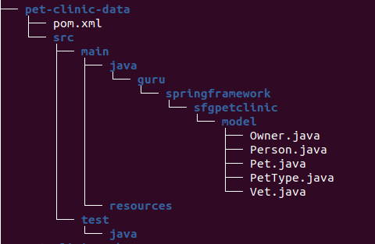Figure 4: package and refactor model

- create a package in pet-clinic-web and refactor application file
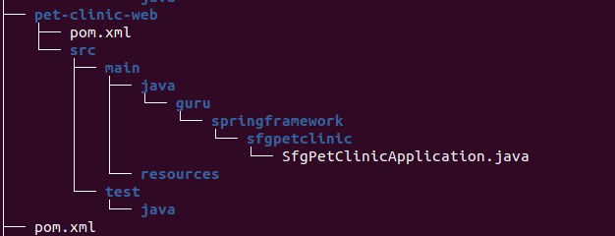

- move static, templates directories and application.properties file from project/resources to pet-clinic-web/resources
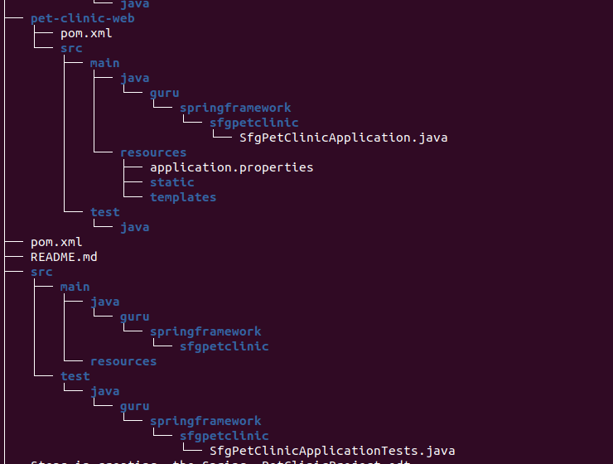Figure 5: move resources to web

- Move test from project to web-test-clinic
(Did not want to refactor when moving só I created the package and copied over the Test file.
- I Then deleted the src in the project root

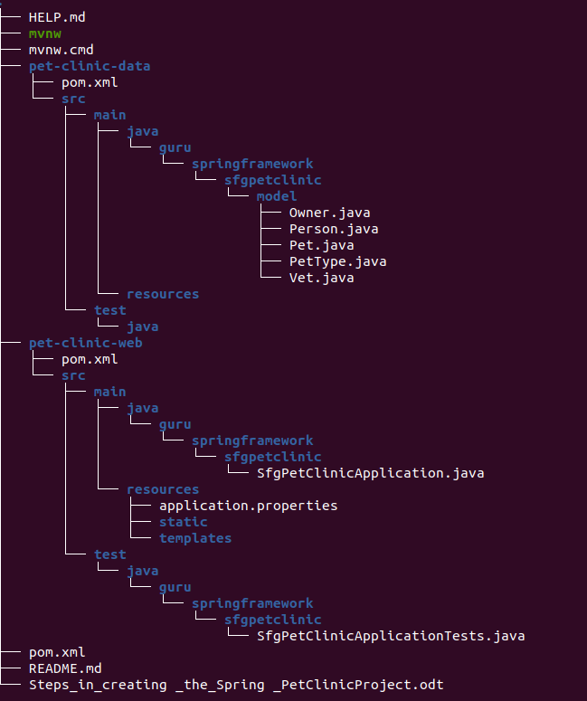Figure 6: Move test and delete src in project root

Action | Info | From Pom | To Pom
Add the folloe=wing | <build>  <plugins>  <plugin>  <groupId>org.springframework.boot</groupId>  <artifactId>spring-boot-maven-plugin</artifactId>  <executions>  <execution>  <goals>  <goal>repackage</goal>  </goals>  </execution>  </executions>  </plugin>  </plugins>  </build> |  | pet-clinic-data

Drawing 6: (sfg-pet-clinic) pom.xml
<?xml version="1.0" encoding="UTF-8"?>
<project xmlns="http://maven.apache.org/POM/4.0.0" xmlns:xsi="http://www.w3.org/2001/XMLSchema-instance"
xsi:schemaLocation="http://maven.apache.org/POM/4.0.0 https://maven.apache.org/xsd/maven-4.0.0.xsd">
<modelVersion>4.0.0</modelVersion>
<parent>
<groupId>org.springframework.boot</groupId>
<artifactId>spring-boot-starter-parent</artifactId>
<version>3.0.0</version>
<relativePath/> <!-- lookup parent from repository -->
</parent>
<groupId>guru.springframework</groupId>
<artifactId>sfg-pet-clinic</artifactId>
<version>0.0.1-SNAPSHOT</version>
<packaging>pom</packaging>
<name>sfg-pet-clinic</name>
<description>SFG Pet Clinic Project</description>
<modules>
<module>pet-clinic-data</module>
<module>pet-clinic-web</module>
</modules>
<properties>
<java.version>17</java.version>
</properties>
<dependencies>
</dependencies>
<build>
<plugins>
<plugin>
<groupId>org.springframework.boot</groupId>
<artifactId>spring-boot-maven-plugin</artifactId>
<configuration>
<excludes>
<exclude>
<groupId>org.projectlombok</groupId>
<artifactId>lombok</artifactId>
</exclude>
</excludes>
</configuration>
</plugin>
</plugins>
</build>
</project>

Drawing 7: (pet-clinic-data) pom.xml
<?xml version="1.0" encoding="UTF-8"?>
<project xmlns="http://maven.apache.org/POM/4.0.0"
xmlns:xsi="http://www.w3.org/2001/XMLSchema-instance"
xsi:schemaLocation="http://maven.apache.org/POM/4.0.0 http://maven.apache.org/xsd/maven-4.0.0.xsd">
<modelVersion>4.0.0</modelVersion>
<parent>
<groupId>guru.springframework</groupId>
<artifactId>sfg-pet-clinic</artifactId>
<version>0.0.1-SNAPSHOT</version>
</parent>
<artifactId>pet-clinic-data</artifactId>
<properties>
<spring-boot.repackage.skip>true</spring-boot.repackage.skip>
</properties>
<dependencies>
<dependency>
<groupId>org.springframework.boot</groupId>
<artifactId>spring-boot-starter-data-jpa</artifactId>
</dependency>
<dependency>
<groupId>com.h2database</groupId>
<artifactId>h2</artifactId>
<scope>runtime</scope>
</dependency>
<dependency>
<groupId>com.mysql</groupId>
<artifactId>mysql-connector-j</artifactId>
<scope>runtime</scope>
</dependency>
<dependency>
<groupId>org.projectlombok</groupId>
<artifactId>lombok</artifactId>
<optional>true</optional>
</dependency>
<dependency>
<groupId>org.springframework.boot</groupId>
<artifactId>spring-boot-starter-test</artifactId>
<scope>test</scope>
</dependency>
</dependencies>
<build>
<plugins>
<plugin>
<groupId>org.springframework.boot</groupId>
<artifactId>spring-boot-maven-plugin</artifactId>
<executions>
<execution>
<goals>
<goal>repackage</goal>
</goals>
</execution>
</executions>
</plugin>
</plugins>
</build>
</project>

Drawing 8: (pet-clinic-web) pom.xml
<?xml version="1.0" encoding="UTF-8"?>
<project xmlns="http://maven.apache.org/POM/4.0.0"
xmlns:xsi="http://www.w3.org/2001/XMLSchema-instance"
xsi:schemaLocation="http://maven.apache.org/POM/4.0.0 http://maven.apache.org/xsd/maven-4.0.0.xsd">
<modelVersion>4.0.0</modelVersion>
<parent>
<groupId>guru.springframework</groupId>
<artifactId>sfg-pet-clinic</artifactId>
<version>0.0.1-SNAPSHOT</version>
</parent>
<artifactId>pet-clinic-web</artifactId>
<dependencies>
<dependency>
<groupId>guru.springframework</groupId>
<artifactId>pet-clinic-data</artifactId>
<version>0.0.1-SNAPSHOT</version>
</dependency>
<dependency>
<groupId>org.springframework.boot</groupId>
<artifactId>spring-boot-starter-actuator</artifactId>
</dependency>
<dependency>
<groupId>org.springframework.boot</groupId>
<artifactId>spring-boot-starter-thymeleaf</artifactId>
</dependency>
<dependency>
<groupId>org.springframework.boot</groupId>
<artifactId>spring-boot-starter-web</artifactId>
</dependency>
<dependency>
<groupId>org.springframework.boot</groupId>
<artifactId>spring-boot-devtools</artifactId>
<scope>runtime</scope>
<optional>true</optional>
</dependency>
<dependency>
<groupId>org.springframework.boot</groupId>
<artifactId>spring-boot-starter-test</artifactId>
<scope>test</scope>
</dependency>
</dependencies>
</project>

Now I commit and push to github message changed to

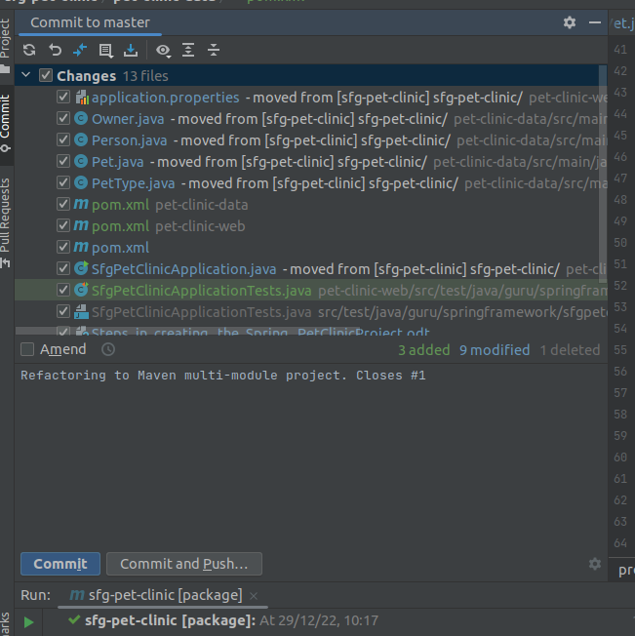Figure 7: commit and push. closes issue #1
Did it manually as above doid noyt work for me

git add .
git commit -m "refactor multi-module maven project. Closes #1"
git push origin

